UNIVERSITY OF CAPE COAST
COLLEGE OF HUMANITIES AND LEGAL STUDIES
SCHOOL OF ECONOMICS
DEPARTMENT OF DATA SCIENCE AND ECONOMIC POLICY
CAPSTONE PROJECT



NAME: JONATHAN KWESI ARTHUR
PROGRAM: MSC. DATA MANAGEMENT AND ANALYS
TITLE: PRECIPITATION PREDICTION MODEL USING MACHINE LEARNING: A CASE STUDY OF ACCRA, CAPE COAST AND KUMASI SYNOPTIC STATION.

ABSTRACT
This research aims to develop a Precipitation prediction model using machine learning techniques: Random Forest Regression and Linear Regression. The data used for this study is obtained from the Ghana Meteorology Agency (GMet), specifically the GMet Monthly Precipitation.csv file, which contains precipitation data from three different meteorological stations in Ghana, Accra, Cape Coast and Kumasi. The goal is to compare the performance of three machine learning algorithms in predicting precipitation and to identify the most accurate model. Jupyter Notebook was used to import the .csv file into Panda DataFrame for the Statistical and Machine Learning Analysis of the precipitation data. Mann-Kendall Trend Test was performed statistical to check for significant changes and also to identify trends in the time series data. a moderate positive correlation (Tau) of 0.258 and a positive slope of 0.02, suggesting the data is increasing over time. Cape Coast had Linear Regression to be the best-performing model, whiles Accra had Random Forest Regression Model performing the best, with the lowest MAE, MSE, and RMSE and Kumasi had ARIMA (Auto Regressive Integrated Moving Average) showing the best performance with the lowest errors. Accra generally shows lower error rates across all models compared to Cape Coast and Kumasi, suggesting that the models may predict more accurately in this region.

Table of Content
Introduction: 1
History: 1.1
Objectives: 2
Methodology: 3
Result and Discussion: 4
Statistical Tests: 4.1
Machine Learning: 4.2
Conclusion: 5

- INTRODUCTION
For many applications, such as agriculture, disaster relief, and daily weather forecasting, precipitation prediction is essential. Planning and decision-making processes can benefit from accurate precipitation forecasts. The main goal of this study is to create a machine learning model that uses historical data from three meteorological stations in Ghana to forecast precipitation.
Evidence of climate change dates back to the early industrial era and is undeniable. According to the UN, climate change is a long-term phenomenon that results in changes to extreme weather patterns, such as temperature, precipitation, and hot or cold temperatures, which can lead to acute weather events, sea level rise, and the extinction of some animal species. Numerous research has been conducted regarding climate change, and our goal is not to quantify or prove its intensity, but rather to forecast changes in its frequency throughout time (Chao & Feng, 2018).
In this sense, the goal of this notebook is to compare the patterns of rainfall along Ghana's coastal plain using machine learning (ML) approaches (Garcia & Patel 2023). A case study of Kumasi, the Cape Coast, and Accra Metropolis. Researchers and governments can comprehend the sources and patterns of Rainfall-flood output with precision in the pattern of rainfall and flooding. There aren't many systems available in Africa to monitor rainfall and subsequent flooding, compared to the many systems in Europe and North America (Kumar & Ghosh 2019). This is explained by the fact that there aren't many weather stations spread out over the majority of African nations or regions.
Over the past ten years, more has been done to comprehend the impact of historical climate change data on both a global and regional scale. Specifically, the estimates of Studies on the effects of climate change on the agricultural, ecological, environmental, and industrial sectors have identified precipitation as a critical component (Smith & Kumar, 2023).
1.1 HISTORY
Ghana, a country located in West Africa, shares boundaries to north with Burkina Faso, to the East with Togo, to the west with Cote D’Ivoire and to the south with the Gulf of Guinea. It has a rich history shaped by its ancient kingdom’s colonization, and modern-day independence. It is found on latitude 7.9465 degrees N and longitude 1.0232 degrees W.
Ghana's dynamic political and economic centre, Accra, is situated at latitude 5.5560 degrees N and longitude 0.1969 degrees W. As the nation's capital, it functions as the centre of government, business, and culture. With scorching temperatures and clearly defined wet and dry seasons, its climate is categorized as tropical savannah climate. Accra experiences two separate rainy seasons due to its bimodal rainfall pattern. There is a longer minor rainy season in September and October, and a major rainy season that runs from April to mid-July. comparatively speaking to other sections of southern Ghana, the city receives comparatively little rainfall each year—roughly 800-1,100 mm (Grant, 2009).
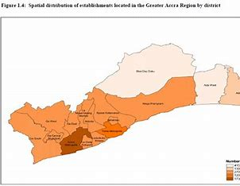
Cape Coast experiences a tropical savannah climate and is situated in Ghana's Central Region, close to the Gulf of Guinea. Its historical significance in the transatlantic slave trade is likewise well-known. The city, like other coastal parts of Ghana, experiences two rainy seasons. It is located at latitude 5.1054 degrees N and longitude 1.2466 degrees W. While the minor rainy season lasts from September to November, the major rainy season spans from April to July. There is roughly 800-1,200 mm of rainfall annually (Lawson, 2013). During the dry season, which is defined by conditions that are dry and dusty, particularly from December to February. The terrain of the city is characterized by a combination of long, picturesque coastline, minor rivers, and rolling hills (Acquah, 2008).

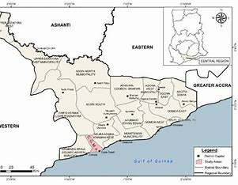

Kumasi is situated in Ghana's southern Ashanti Region at latitude 6.6885 degrees north and longitude 1.6244 degrees west. The climate of the city is like that of a tropical rainforest. As Kumasi is inland and has a more humid climate with high annual rainfall, it differs from coastal towns like Accra and Cape Coast. It is well-known for having a lot of rain, especially during the wet seasons. There is a secondary rainy season from September to November, while the primary rainy season runs from March to July. It is one of the wettest areas of Ghana with an average annual rainfall of 1,300 to 1,600 mm. The Harmattan winds cause a dry season to last from December to February. Kumasi's humidity levels are still greater.

- OBJECTIVES
- Develop an understanding of the relationships between different Rainfall - flood Model prediction.

- Provide valuable insights to authorities, policymakers, and individuals to facilitate better decision-making regarding flood risk management and mitigation strategies.

Observational data are measurements made directly from devices such as satellites, rain gauges, and thermometers. They depict real-world physical quantities at certain points in time and space. These can be scarce, particularly in isolated or difficult-to-reach areas. Certain regions might completely lack observational data.

- METHODOLOGY
This chapter outlines the outlines the methodology employed in analysing three different machine learning algorithms in predicting rainfall for three synoptic stations in Ghana. The study primary uses secondary observed rainfall data for three study areas Accra, Cape Coast and Kumasi respectively from the Ghana Meteorological Agency. This was to ensure a collection of reliable and comprehensive demographic data, for meaningful comparison across regions.
The research adopts descriptive, quantitative and machine learning design, which is well suited for analysing the prediction of rainfall for observed data from three synoptic stations (Liu., & Wang, (2022), Zhang & Ye, (2021) and Leger-Goodes et al, 2023).

- Data Collection:
Data for three synoptic stations ‘Accra, Cape Coast, and Kumasi’ were obtained from the Ghana Meteorological Agency, respectively. The format of the data was Comma Delimiter (.csv). After that, it was imported into Jupyter Notebook for use in data analysis techniques including ARIMA, Random Forest, and Linear Regression.

- Data Preprocessing:
In an Anaconda Jupyter Notebook, the Python programming language was used to handle missing values. In order to guarantee that the datasets for every station have a corresponding period of years, a normalization and scaling operation was also carried out. The yearly precipitation mean was also calculated.

- Exploratory Data Analysis (EDA):
Statistical analysis of the precipitation data obtained for the three (3) synoptic stations was done using the python programming language to analyse the trends and patterns. Also, the data was visualised using matplot library and plotly library.
- Model Selection:
In this procedure, two machine learning algorithm were employed to train the model: the Random Forest Regressor and the Linear Regressor. This was to help predict future rainfall for Accra, Cape Coast and Kumasi using station precipitation data acquired from the three cities respectively. The models selected for machine learning algorithms are:

- ARIMA Model:
Auto Regressive Integrated Moving Average is referred to as ARIMA. It's a well-liked statistical technique for forecasting time series. Future points in a time series can be understood and predicted using ARIMA models. In order to forecast future values, this model makes advantage of the correlation between an observation and several lagged observations, or past values. For instance, the AR component utilized historical rainfall data to forecast rainfall.
In order to render the data stationary to ensure that statistical parameters like variance and mean remain constant throughout time, the data is also differenced. Many time series models depend on stationarity in order to function successfully. the relationship between a lagged set of observations and a residual error from a moving average model. This aids in removing or smoothing down the data's noise.
The ARIMA model is defined by three parameters:
$$(p,d,q):Y_{t}=c+ϕ_{1}Y_{t-1}+ϕ_{2}Y_{t-2}+…+ϕ_{p}Y_{t-p}+ϵ_{t}+θ_{1}ϵ_{t-1}+θ_{2}ϵ_{t-2}+…+θ_{q}ϵ_{t-q}$$
( p ): Number of lag observations (Auto Regression part)
( d ): Degree of differencing (Integration part)
( q ): Size of the moving average window (Moving Average part of the model)
($ϕ_{1}$ ): Coefficients for the AR terms
( $θ_{1}$): Coefficients for the MA terms
( $ϵ_{t-q}$ ): Error term ( p ) is the number of lag observations included in the model (Auto Regressive part).
- Linear Regression Model:
A dependent variable and one or more independent variables can be modelled using the statistical technique of linear regression. Finding the regression line, or best-fitting straight line between the data points, is the aim. The equation of the line is typically written as:
$$Y=β_{0}+β_{1}X_{1}+β_{2}X_{2}+…+β_{n}X_{n}+ϵ$$
where:
( $Y$ ): Dependent variable
($β_{0}$): Intercept
($β_{1}, β_{2}, β_{n}$): Coefficients for the independent variables ( $X_{1}, X_{2}, X_{n}$ )
($ϵ$ ): Error term.

- Random Forest Regression Model:
An ensemble learning technique called Random Forest Regression makes predictions by utilizing a number of decision trees. A random subset of the data is used to build each tree, and the average of all the individual trees' forecasts is used to make the final prediction.

$$\hat{Y}=\frac{1}{N}\sum_{i=1}^{N}{(}{\hat{Y}}_{i})$$
( N ): Number of trees in the forest
(${\hat{Y}}_{i}$): Prediction from the ( i )-th tree

- Model Comparing:
The data for the three synoptic stations ‘Accra, Cape Coast, and Kumasi’ was divided into training and testing sets in order to train the models.
Evaluate the results of Random Forest, Linear, and ARIMA regression. use the Mean Absolute Error (MAE), Mean Square Error (MSE), and R-Squared Value to compare the performance of the trained and tested datasets.

- RESULTS AND DISCUSSION
Yearly Precipitation
The graph shows yearly precipitation data for Cape Coast, Accra, and Kumasi from 1991 to 2022. Each location is represented by a different coloured line: Cape Coast (blue), Accra (orange), and Kumasi (green).
- Cape Coast shows a sharp increase in precipitation around 2021, peaking just above 6 mm. This is the highest point on the graph, with the lowest peak around 2020. The precipitation levels show considerable fluctuations over the years, with several peaks and troughs.

- The precipitation levels in Accra show more moderate changes compared to Cape Coast. There are no extreme peaks, and the values remain relative troughs. There are noticeable peaks around 1997 and 2008 and 2022, but these are not as pronounced as those in Cape Coast.

- Kumasi shows a relatively stable trend with moderate fluctuations. The precipitation levels do not reach the extremes seen. There are peaks around 2007 and 2021, but these are moderate compared to Cape Coast.

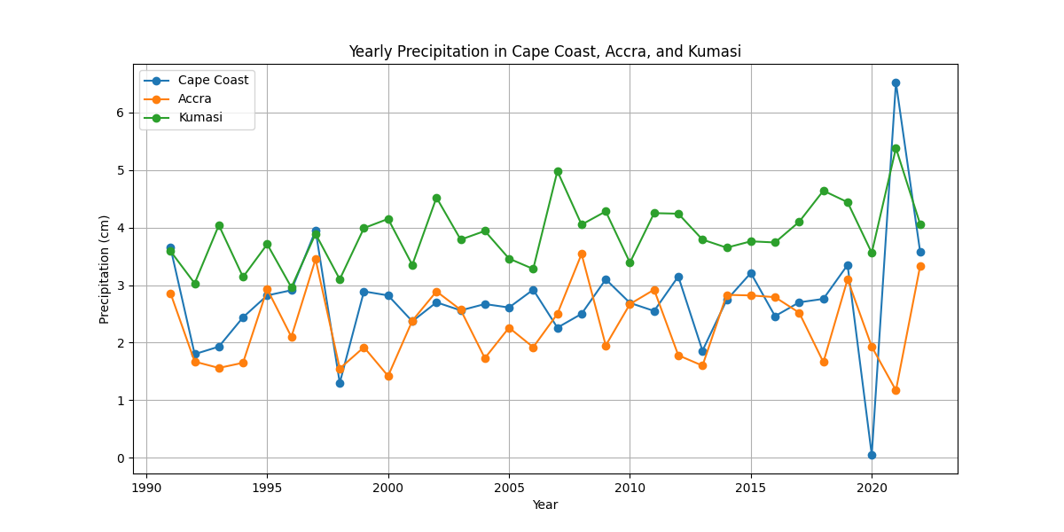
Figure 1 Yearly Precipitation (1991-2022)
Yearly Mean Precipitation Trend
The figure below shows the yearly mean precipitation for the year 1991 to 2022 for the three stations. The highest peak occurs around 2023, where precipitation reaches approximately 4.5 mm. This suggests an unusually high amount of rainfall in that year. Other notable peaks are seen around 1998 and 2020, with precipitation levels reaching around 3.8 mm - 4 mm.
There are significant dips around 1999 and 2021, where precipitation drops to near or just below 2 mm. These years experienced relatively low rainfall. The graph shows considerable variability in precipitation from year to year, which could be influenced by various climatic factors such as topography, urbanisation, degradation and many more.

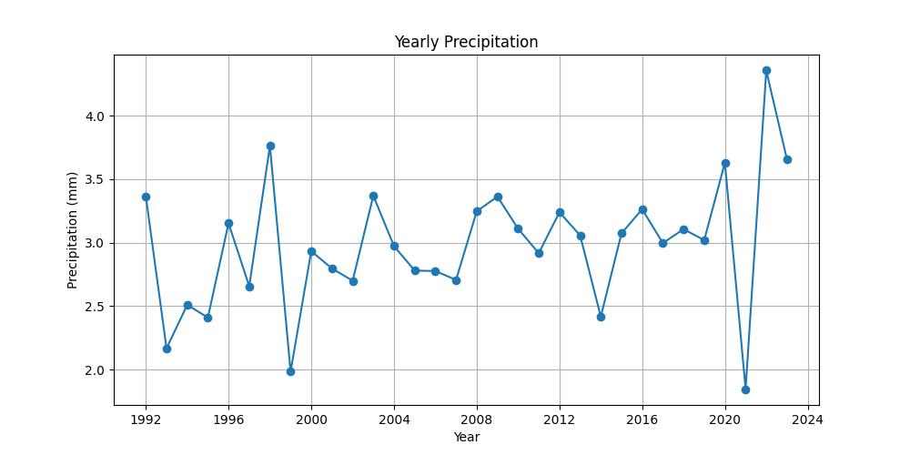
Figure 2 Yearly Mean Precipitation Trend

4.1 STATISTICAL TESTS
Mann-Kendall Analysis: Perform statistical tests to check for significant changes and also to identify trends in the time series data (Gilbert, 1987). This test is a non-parametric test used to identify a moderate positive correlation (Tau) and a positive slope trend in the yearly rainfall data, suggesting the data is increasing over time. This help test the data as there are no other factors being considered aside the synoptic rainfall data obtained for the three stations (Kendall, 1975).
PARAMETER | VALUE | EXPLANATION
Trend | Increasing | Indicates the direction of the trend in the data.
Hypothesis test | True | Hypothesis test result: True means the null hypothesis is rejected, indicating a significant trend in the data.
p-value | 0.039 | 0.039 is the p-value of the test. A p-value less than a significance level of 0.05 indicates that the observed trend is statistically significant at the 5% level.
Z score | 2.059 | Standardized test statistic indicates 2.059 (Z-score) which is a measure of how far away the observed trend is from the null hypothesis of no trend. A higher absolute value of Z indicates a stronger trend.
Tau | 0.258 | Kendall’s Tau, a measure of correlation that ranges from -1 to 1 was 0.258. A positive Tau indicates an increasing trend, while a negative Tau indicates a decreasing trend. Here, Tau is about 0.258, suggesting a moderate positive correlation.
S statistic | 128 | Mann-Kendall S statistic, the difference between the number of positive and negative differences. 128.0. The S statistic is the sum of the signs of differences between all possible pairs of observations.
Variance of S | 3802.666667 | Variance of S, used to calculate the z statistic.
Slope | 0.022962972 | The estimated slope of the trend.
Figure 3 Mann-Kendall Analysis
Yearly Heatmap Precipitation
The heatmap provides a visual representation of the variability in yearly precipitation from 1991 to 2022. The colours make it easy to identify years with unusually high or low precipitation. The significant contrast between years like 2020 and 2021 highlights extreme variability in precipitation, potentially due to climatic or environmental changes during that period.
The heatmap shows significant variability in precipitation from year to year. Years such as 1999, 2010, and 2020 are marked with cooler blue tones, suggesting below-average precipitation compared to other years.
The years 1997, 2019, and 2021 stand out with darker red shades, indicating very high precipitation. 2021 is the year with the highest precipitation value (4.4 mm) on the heatmap, marked by a deep red colour. Also, Years like 1993, 1995, and especially 2020, show blue shades, indicating lower precipitation. 2020, with a value of 1.8 mm, is one of the years with the lowest precipitation, indicated by a dark blue shade.
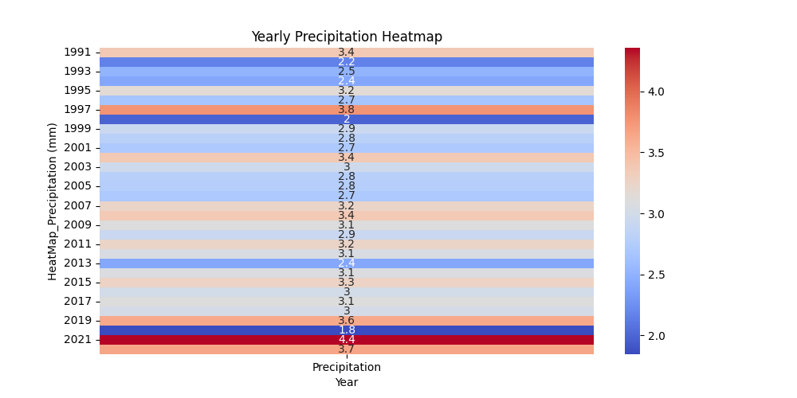
Figure 4 Heatmap Precipitation

4.2 MACHINE LEARNING
Exploratory analysis for ARIMA Model, Linear Regression Model and Random Forest Regression Model.

Model | Mean absolute Error (MAE) | Mean Squared Error (MSE) | Root Mean Square (RMSE)
ARIMA (Cape Coast) | 1.556 | 4.366 | 2.089
ARIMA (Accra) | 0.764 | 0.669 | 0.818
ARIMA (Kumasi) | 0.49 | 0.371 | 0.609
Linear Regression (Cape Coast) | 1.233 | 2.918 | 1.708
Linear Regression (Accra) | 0.658 | 0.524 | 0.724
Linear Regression (Kumasi) | 0.614 | 0.621 | 0.788
Random Forest (Cape Coast) | 1.269 | 3.369 | 1.835
Random Forest (Accra) | 0.588 | 0.553 | 0.744
Random Forest (Kumasi) | 0.644 | 0.872 | 0.934
Table 2 the models mean absolute error, mean squared error and root mean square error

Mean Absolute Error (MAE): It measures the average differences of the errors in a set of predictions (between the predicted value and the actual value), without considering their direction. It's a linear score where all individual differences are weighted equally. Lower values indicate better model performance.

$\text{MAE}=\frac{1}{n}\sum_{i=1}^{n}{(}∣y_{i}-{\hat{y}}_{i}∣$)

Mean Squared Error (MSE): It measures the average of the squares of the errors (the difference between the actual and predicted values). It gives more weight to larger errors. Lower values are better, indicating more accurate predictions.
$$\text{MSE}=\frac{1}{n}\sum_{i=1}^{n}{(}(y_{i}-{\hat{y}}_{i})^{2})$$

Root Mean Squared Error (RMSE): It is the square root of MSE. It gives a measure of the error in the same units as the original data, making it easier to interpret. Like MSE, smaller values are better.
$\text{RMSE}=\sqrt{\frac{1}{n}\sum_{i=1}^{n}{(}(y_{i}-{\hat{y}}_{i})^{2}}$)

- ARIMA (Auto Regressive Integrated Moving Average) from the table above:
Cape Coast: MAE: 1.556, MSE: 4.366, RMSE: 2.089
ARIMA shows the highest errors (both MAE, MSE, and RMSE) for Cape Coast, indicating that this model is not performing well for this location.
Accra: MAE: 0.764, MSE: 0.669, RMSE: 0.818
The model performs much better in Accra, with significantly lower error metrics.
Kumasi: MAE: 0.49, MSE: 0.371, RMSE: 0.609
This is the best performance of ARIMA across all locations, with very low errors

- Linear Regression from the table above:
Cape Coast: MAE: 1.233, MSE: 2.918, RMSE: 1.708
Linear Regression performs better than ARIMA in Cape Coast, but still has significant errors.
Accra: MAE: 0.658, MSE: 0.524, RMSE: 0.724
Like ARIMA, Linear Regression has lower errors in Accra, showing good performance.
Kumasi: MAE: 0.614, MSE: 0.621, RMSE: 0.788
Errors are slightly higher for Kumasi compared to Accra but still within an acceptable range

- Random Forest from the table above:
Cape Coast: MAE: 1.269, MSE: 3.369, RMSE: 1.835
Random Forest outperforms ARIMA in Cape Coast but does not perform as well as Linear Regression.
Accra: MAE: 0.588, MSE: 0.553, RMSE: 0.744
Random Forest has the lowest errors in Accra compared to the other models, indicating it is the best model for this location.
Kumasi: MAE: 0.644, MSE: 0.872, RMSE: 0.934
Random Forest performs slightly worse than the other models in Kumasi, showing a relatively higher error rate.
The best performing model varies depending on the region. Therefore, recommend other characteristics such temperature, wind, topography and other data of the data should be considered in further analysis for each region when choosing the most appropriate model.

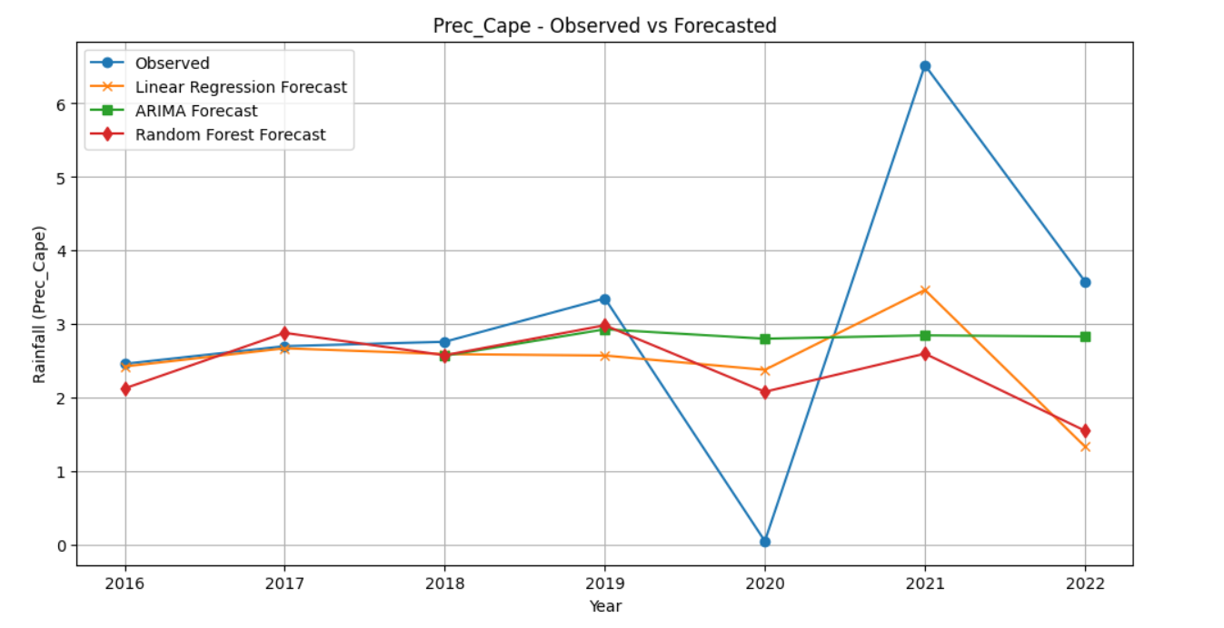

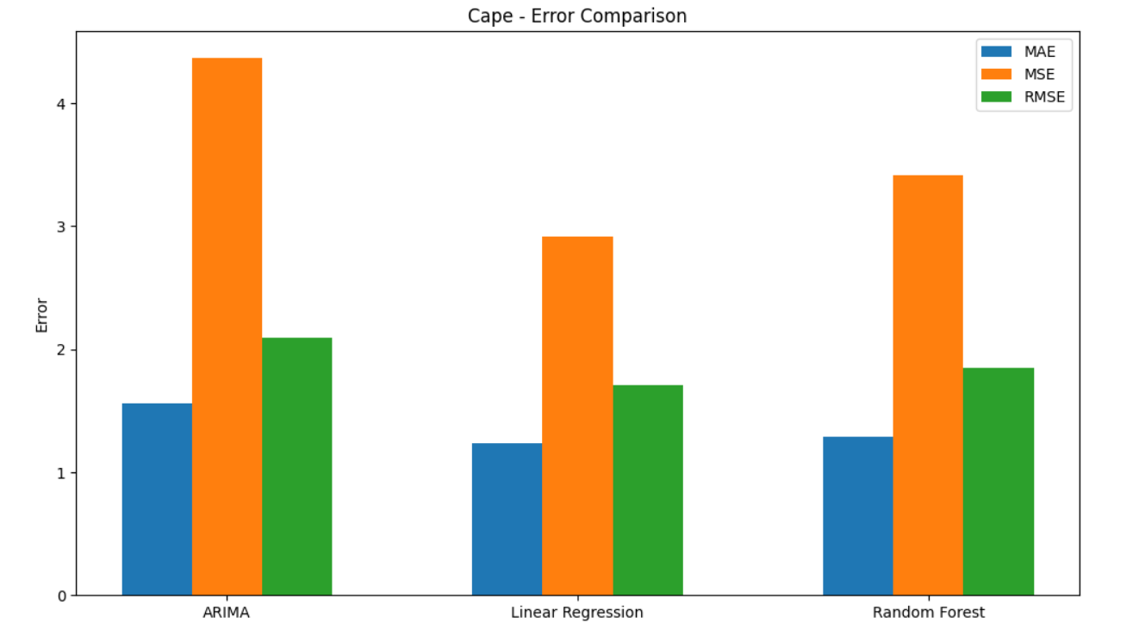

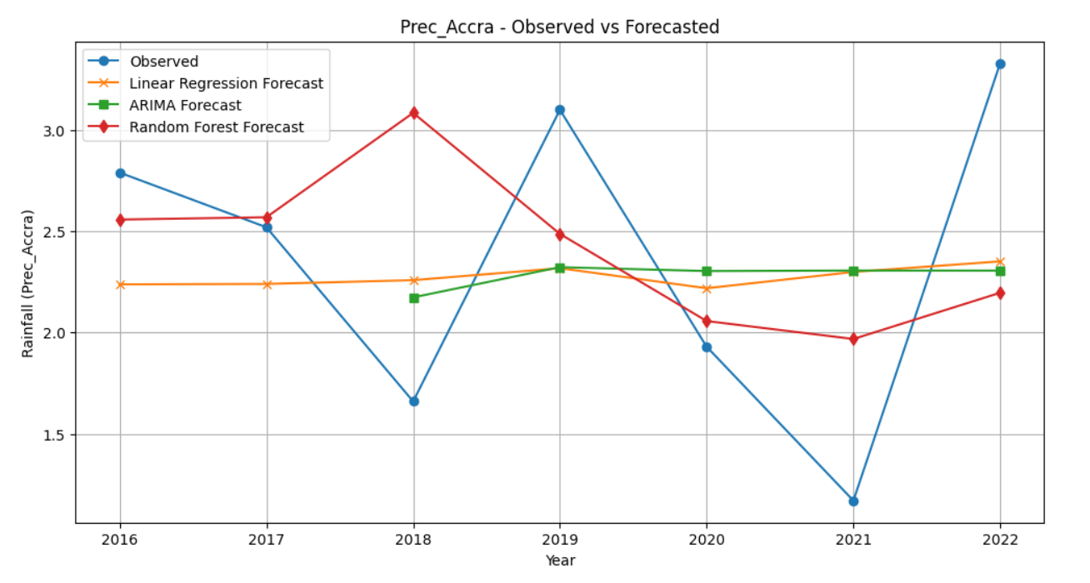

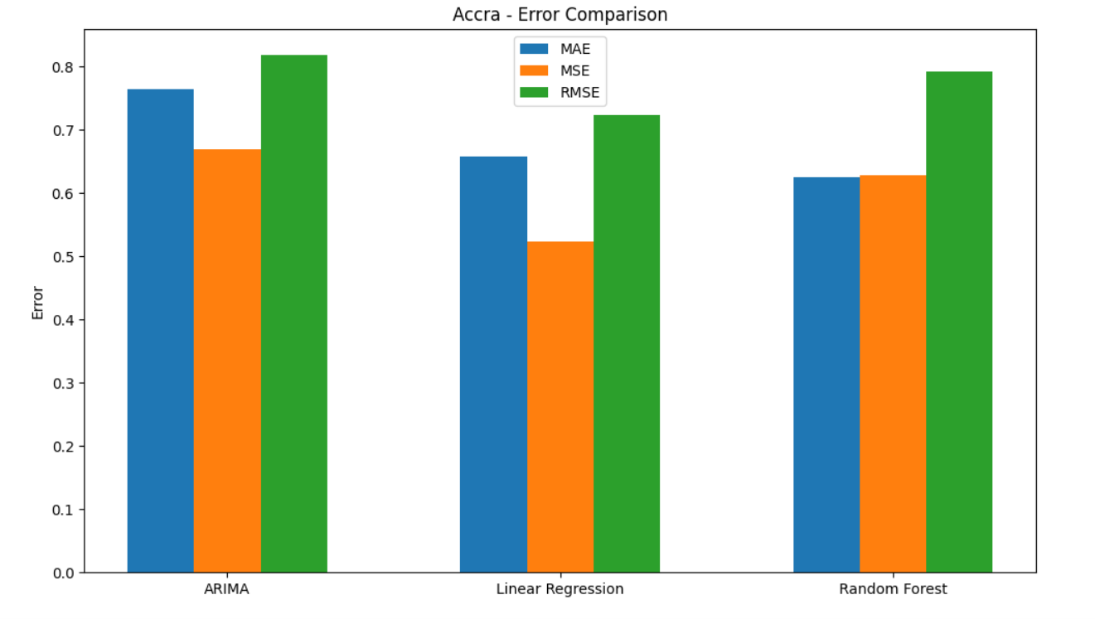

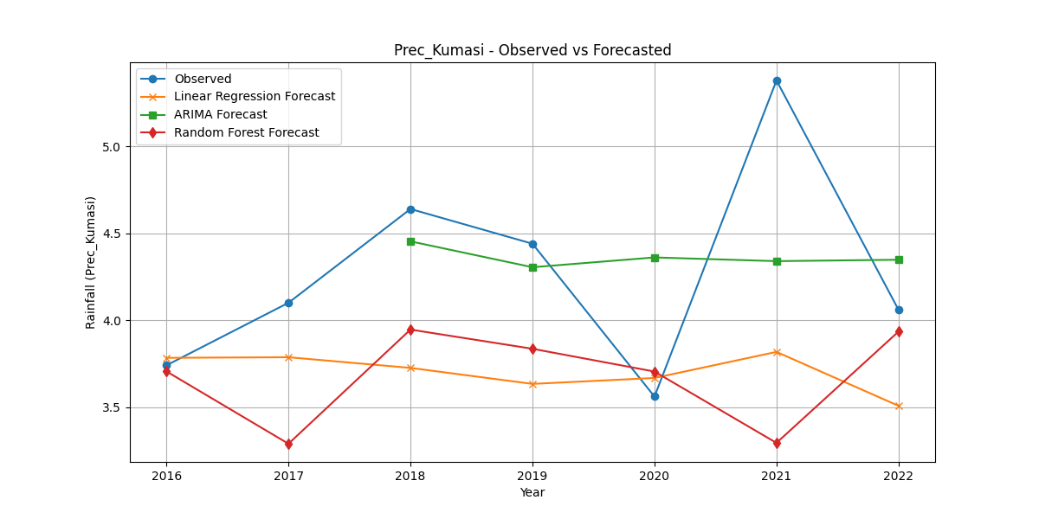

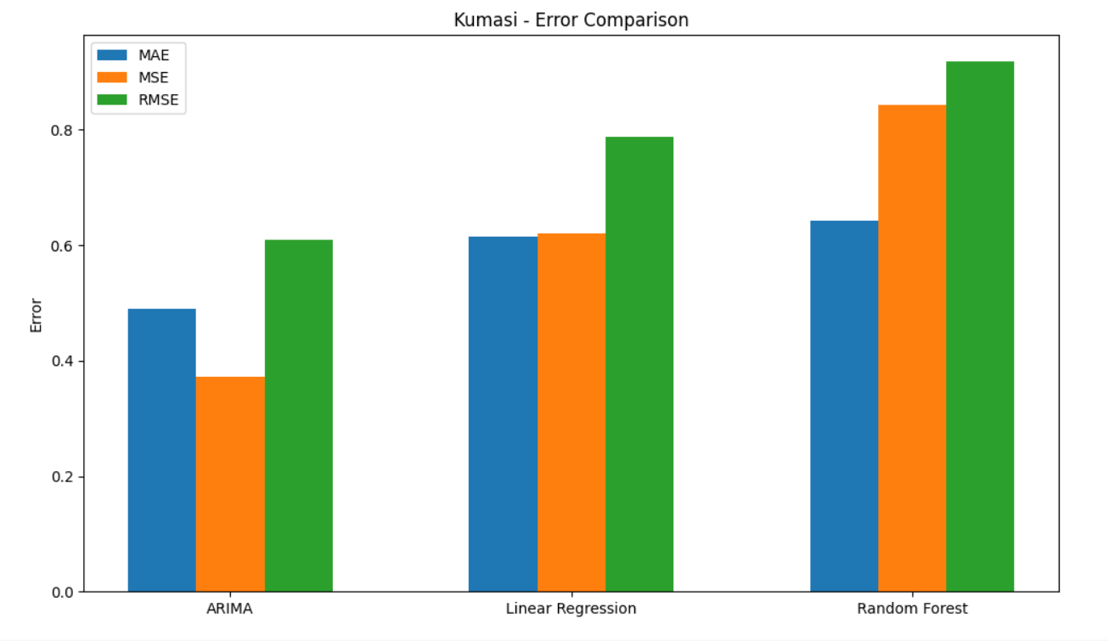

- CONCLUSION
The rainfall pattern in studied for the three (3) synoptic stations showed a positive increasing trend respectively for future forecast which can be attributed to various factors such as difference in topography, atmospheric pollutants, land use and degradation. Also, statistically, Mann-Kendall Trend Test was performed statistical to check for significant changes and also to identify trends in the time series data. a moderate positive correlation (Tau) of 0.258 and a positive slope of 0.02, suggesting the data is increasing over time.
Cape Coast had Linear Regression seems to be the best-performing model, whiles Accra had Random Forest performs the best, with the lowest MAE, MSE, and RMSE and Kumasi had ARIMA showing the best performance with the lowest errors. Accra generally shows lower error rates across all models compared to Cape Coast and Kumasi, suggesting that the models may predict more accurately in this region. ARIMA performs better for Kumasi, while Random Forest excels in Accra.
In all, Kumasi has the highest average precipitation and the lowest variability with a standard deviation of 0.553 indicating more consistent rainfall. Cape Coast showed the highest variability of 0.993 standard deviation, with extreme values of 0.05 minimum rainfall and a maximum of 6.52 suggesting occasional very low and high precipitation years.
Each model has varying levels of success in prediction depending on the location and human activities, and Random Forest generally outperforms the other models in Accra, while Linear Regression and ARIMA perform well in Cape Coast and Kumasi respectively. There are some limitations to these models that can further be researched and developed due to unavailability of precipitation data, variability of weather patterns, and model generalization.

YEALY MEAN PRECIPITATION DATA
YEAR | Cape Precipitation | Accra Precipitation | Kumasi Precipitation
31/12/1991 | 3.65 | 2.86 | 3.59
31/12/1992 | 1.8 | 1.67 | 3.03
31/12/1993 | 1.93 | 1.56 | 4.04
31/12/1994 | 2.44 | 1.65 | 3.14
31/12/1995 | 2.82 | 2.93 | 3.71
31/12/1996 | 2.91 | 2.1 | 2.96
31/12/1997 | 3.95 | 3.45 | 3.89
31/12/1998 | 1.3 | 1.55 | 3.1
31/12/1999 | 2.89 | 1.92 | 3.99
31/12/2000 | 2.82 | 1.42 | 4.15
31/12/2001 | 2.37 | 2.38 | 3.35
31/12/2002 | 2.7 | 2.89 | 4.52
31/12/2003 | 2.56 | 2.57 | 3.79
31/12/2004 | 2.67 | 1.73 | 3.94
31/12/2005 | 2.61 | 2.26 | 3.46
31/12/2006 | 2.92 | 1.92 | 3.28
31/12/2007 | 2.26 | 2.5 | 4.98
31/12/2008 | 2.5 | 3.54 | 4.05
31/12/2009 | 3.1 | 1.95 | 4.28
31/12/2010 | 2.69 | 2.67 | 3.39
31/12/2011 | 2.55 | 2.92 | 4.25
31/12/2012 | 3.15 | 1.78 | 4.24
31/12/2013 | 1.86 | 1.6 | 3.79
31/12/2014 | 2.74 | 2.83 | 3.65
31/12/2015 | 3.21 | 2.82 | 3.76
31/12/2016 | 2.46 | 2.79 | 3.74
31/12/2017 | 2.7 | 2.52 | 4.1
31/12/2018 | 2.76 | 1.66 | 4.64
31/12/2019 | 3.35 | 3.1 | 4.44
31/12/2020 | 0.05 | 1.93 | 3.56
31/12/2021 | 6.52 | 1.17 | 5.38
31/12/2022 | 3.58 | 3.33 | 4.06

This table describe the dataset giving into detail the minimum and maximum precipitation, the mean, standard deviation (std).
 | Cape Precipitation | Accra Precipitation | Kumasi Precipitation
count | 32.00 | 32.00 | 32.00
mean | 2.744 | 2.312 | 3.882
std | 0.993 | 0.652 | 0.553
min | 0.05 | 1.17 | 2.96
25% | 2.455 | 1.715 | 3.535
50% | 2.7 | 2.32 | 3.84
75% | 2.965 | 2.8375 | 4.173
max | 6.52 | 3.54 | 5.38

REFERENCE
Acquah, H. "The Climate of Ghana." Journal of Climatology and Meteorology, 2008.
Chao Q, Feng A. Scientific basis of climate change and its response. Global Energy Interconnection. 2018; 1: 420–427. https://doi.org/10.14171/j.2096- 5117.gei.2018.04.002
Chen, J., Li, Y., & Zhang, X. (2020). Application of machine learning techniques for precipitation forecasting: A case study. Atmospheric Research, 234, 104691. https://doi.org/10.1016/j.atmosres.2019.104691
Davis, M., & Chen, X. (2024). Enhancing forecasting accuracy with a moving average hybrid model: A comparative study of ARIMA, LSTM, and random forest. SN Computer Science, 5, Article 3060. https://doi.org/10.1007/s42979-024-03060-4
Dawson, A., Ford, R. A., & Palmer, S. E. (2021). Precipitation prediction using machine learning methods: A comparative study. Journal of Hydrology, 603, 126876. https://doi.org/10.1016/j.jhydrol.2021.126876
Garcia, R., & Patel, S. (2023). A comparative study on different machine learning algorithms for stock price prediction: Linear regression, SVM, and random forest. In Proceedings of the International Conference on Data Science and Applications (pp. 441-450). https://doi.org/10.1007/978-981-99-1479-1_44
Gilbert, R.O., 1987. Statistical methods for environmental pollution monitoring. Van Nostrand
Reinhold, New York.
Goomer, R., & Ramanna, S. (2024). Exploring machine learning approaches for precipitation prediction: Post processing of daily accumulated North American forecasts. Lecture Notes in Networks and Systems, 1052, 53-63. https://doi.org/10.1007/978-3-031- 64776-5_6
Grant, Richard. Globalizing City: The Urban and Economic Transformation of Accra, Ghana. Syracuse University Press, 2009.
Hoegh-Guldberg, O., Jacob, D., Taylor, M., Bindi, M., Brown, S., Camilloni, I., et al. (2019). Impacts of 1.5°C global warming on natural and human systems. In Global Warming of 1.5°C: An IPCC special report on the impacts of global warming of 1.5°C above pre- industrial levels and related global greenhouse gas emission pathways, in the context of strengthening the global response to the threat of climate change, sustainable development, and efforts to eradicate poverty. United Nations Intergovernmental Panel on Climate Change (IPCC).
Kendall, M.G., 1975. Rank correlation methods, 4th ed. Charles Griffin, London.
Kumar, A., & Ghosh, S. (2019). Precipitation prediction using machine learning: A comparative study. Theoretical and Applied Climatology, 137(1-2), 1-15. https://doi.org/10.1007/s00704-018-2589-9
Lawson, Rachel. Historical Geography of Cape Coast Castle, Ghana. University of Toronto Press, 2013.
Leger-Goodes T, Malboeuf-Hurtubise C, Hurtubise K, Simons K, Boucher A, Paradis P-O, et al. (2023) How children make sense of climate change: A descriptive qualitative study of eco anxiety in parent-child dyads. PLoS ONE 18(4): e0284774. https://doi.org/10.1371/journal. pone.0284774
Liu, P., Li, Z., & Hong, Y. (2022). Deep learning for precipitation prediction: A case study of convolutional LSTM networks. IEEE Transactions on Geoscience and Remote Sensing, 60, 1-13. https://doi.org/10.1109/TGRS.2021.3089411.
Liu, H., Yang, S., & Wang, X. (2020). A hybrid machine learning model for predicting precipitation events based on meteorological data. Atmospheric Research, 239, 104897. https://doi.org/10.1016/j.atmosres.2020.104897
McCaskie, T.C. State and Society in Pre-Colonial Asante. Cambridge University Press, 1995.
Silva, R. A., & Lima, M. A. (2023). Predicting precipitation using machine learning techniques: A case study in the Amazon Basin. Journal of Hydrology, 614, 128456. https://doi.org/10.1016/j.jhydrol.2023.128456
Smith, J., & Kumar, P. (2023). A review of the application of hybrid machine learning models to rainfall forecasting. Environmental Monitoring and Assessment, 195, Article 8 35. https://doi.org/10.1007/s40808-023-01835-x
United Nations. (n.d.). What is climate change? United Nations. Retrieved from https://www.un.org/en/climatechange/what-is-climate-change.
Zhang, Y., & Ye, A. (2021). Machine learning for precipitation forecasts postprocessing: Multimodal comparison and experimental investigation. Journal of Hydrometeorology, 22(11), 3065-3085. https://doi.org/10.1175/JHM-D-21-0096.1

